The JavaScript Array

***a) Create the two arrays below, spelled exactly as they are given. This will form the start for all the following questions.***

*var boys = ["Peter", "lars", "Ole"];*

*var girls = ["Janne", "hanne", "Sanne"];*



***b) Create a new array called all, which should be a concatenation of the two arrays given above, starting with the boys and ending with the girls.***

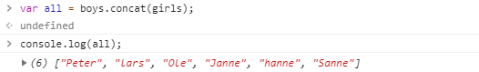

***c) The array type has a cool method to reduce an array into a single string*** [***join(***](https://developer.mozilla.org/en-US/docs/Web/JavaScript/Reference/Global_Objects/Array/join)***)***

***Create a comma separated string containing all the names from the all-array, separated by commas.***

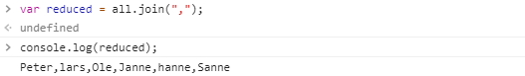

***Create a hyphen (-) separated string containing all the names from the all-array, separated by hyphens.***

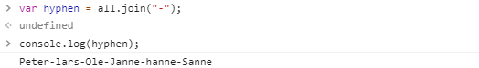

***d) Add the names Lone and Gitte to the end of the array***

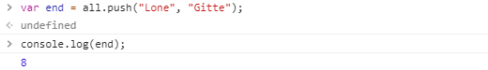

***e) Add the names Hans and Kurt to the start of the array***

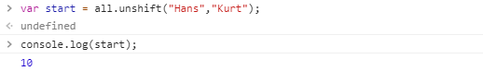

***f) Remove the first name in the array (Hans)***

***g) Remove the last name from the array (Gitte)***

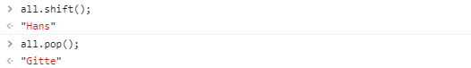

***h) Remove Ole and Janne from the middle of the array***

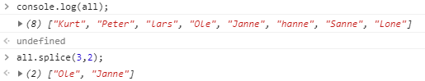

***i) Reverse the all array, so that the girls come first***



***j) Sort the array***



***k) The default sort algorithm doesn’t handle the situation where the name can be either capitalized or not. Write a user-defined sort method to fix this problem.***

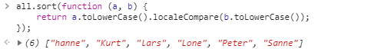

**Array methods with callbacks (there are many)**

***l)*** ***Convert all the names in the array to uppercase.***

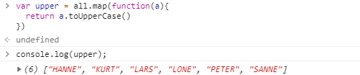

***m) Create a new array containing all the names that start with either “l” or “L”***

***(hint: use the filter function with a sufficient callback).***

